Vendor’s Instruction
Contents
Vendor’s Instruction 1
Participation in purchase 2
Search for purchase 2
View announcement 3
Clarification of the provisions of the documentation for the methods of procurement for "Unlimited bidding", "limited bidding", "Request for quotations" 5
Discuss the documentation provisions for a "Single source" procurement method 7
Create and sbmit the bid 7
Add lots to participate in purchase 9
Delete and edit a bid draft 10
Attaching mandatory documents to participate in purchase 10
Create a purchase participation agreement 12
Generating Technical Specification 13
Filling the "Delivery terms" document. 15
Generate a lot list 16
Fill in a price quote 17
Bid submission 17
Clarification of the procurement methods for "Request for quotations", "limited bidding", "Tender with unlimited participation" 18
Withdrawal of bids 20
Filing a complaint by a vendor on the public procurement web portal 22

Participation in purchase

Search for purchase
Vendor must search for the required purchase to submit a bid. To do this, you need to go to the home page of your private account from the menu and select the "Search announcementa" section. Bid submission is available to a user with the "Vendor" role. To participate in procurement with "Pocurement for domestic manufacturers", vendor must have an indication in the attributes of the organization.
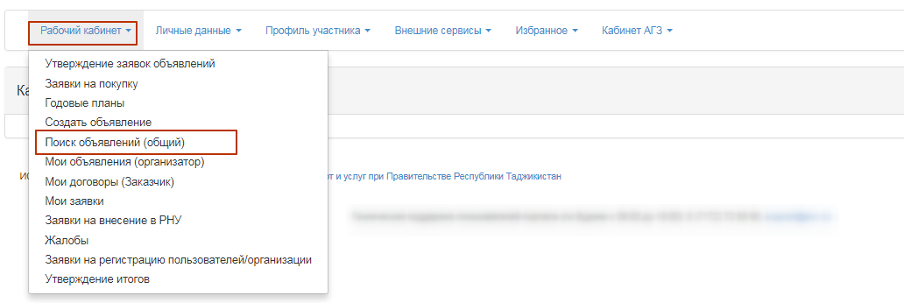
The purchase page is displayed on the screen. You can search for the desired purchase by using a set of filters, and click the "Show Search" button. Just specify one or more search criteria, and click the "Search" button. If you want to change the search criteria, click the "Reset Search Settings" button.
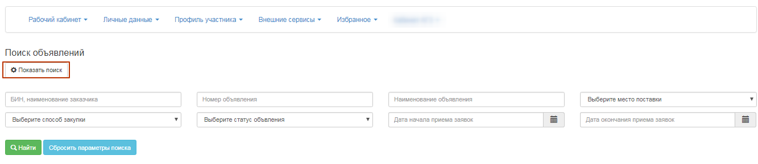
After the search results are available, you must click the active link in the "Announcement name" field to view purchase information.
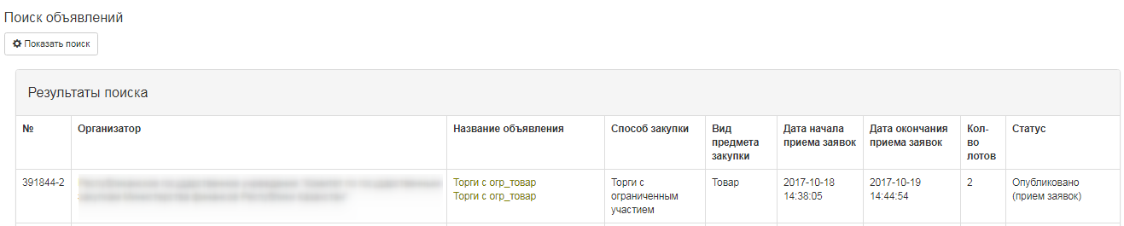

View announcement
Announcement view form contains information about the purchase deadline, name, announcement number, date of publication, general information, validity period of the bid, and terms of delivery with lots section.
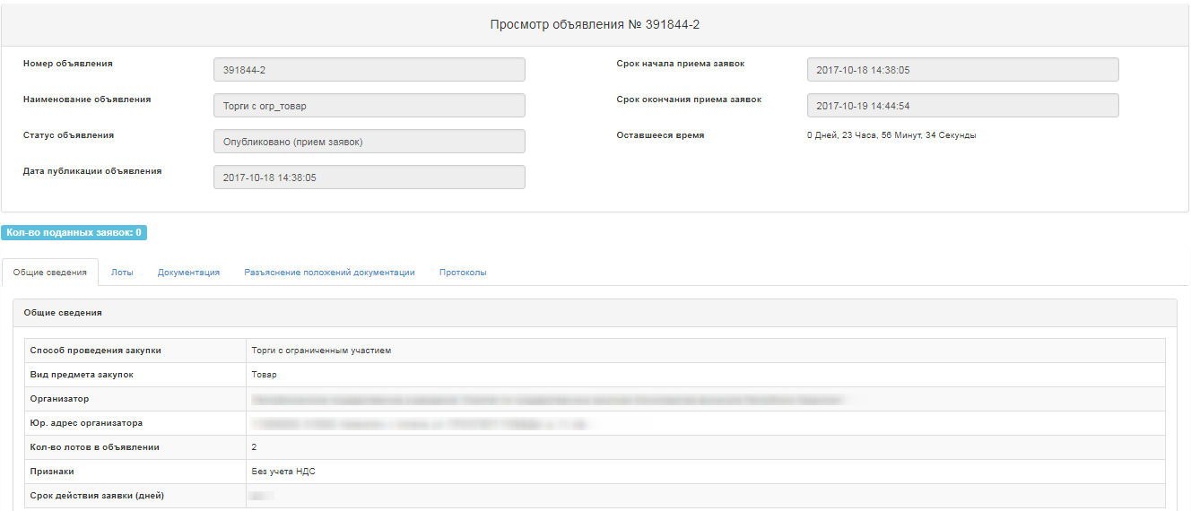
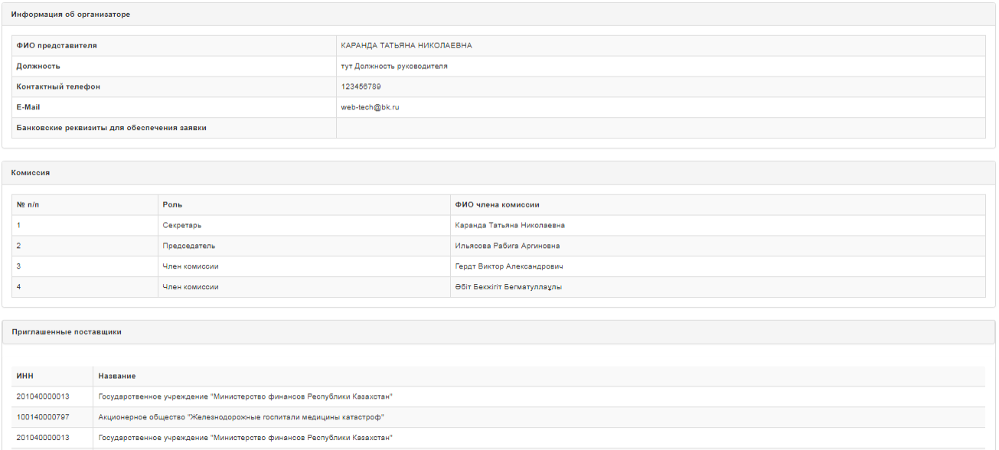
"General information" tab displays general information about the purchase, Facilitator, members of the Commission, and invited vendors.
ATTENTION! Invited vendors are displayed only for single source and limited bidding methods. Bid submission in the specified methods will be available only to the vendors that are specified in the announcement.
On the "Lots" tab, you can see a list of lots on announcement, and click the active link of the lot number for a more detailed view.
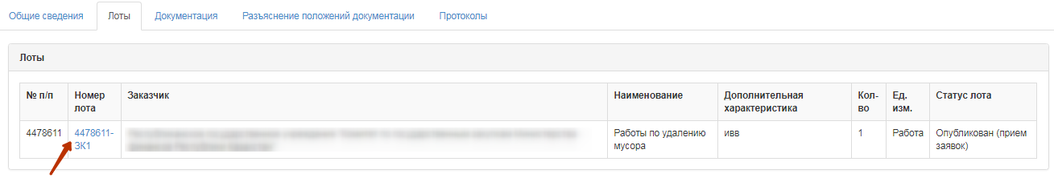
To view the documentation, in the "Documentation" section of the announcement, click "Request documentation". Documentation request is available in announcements that have a status of "Published", "Published. Call for bids". Access to vendor documentation is available if the vendor balance has the required amount.
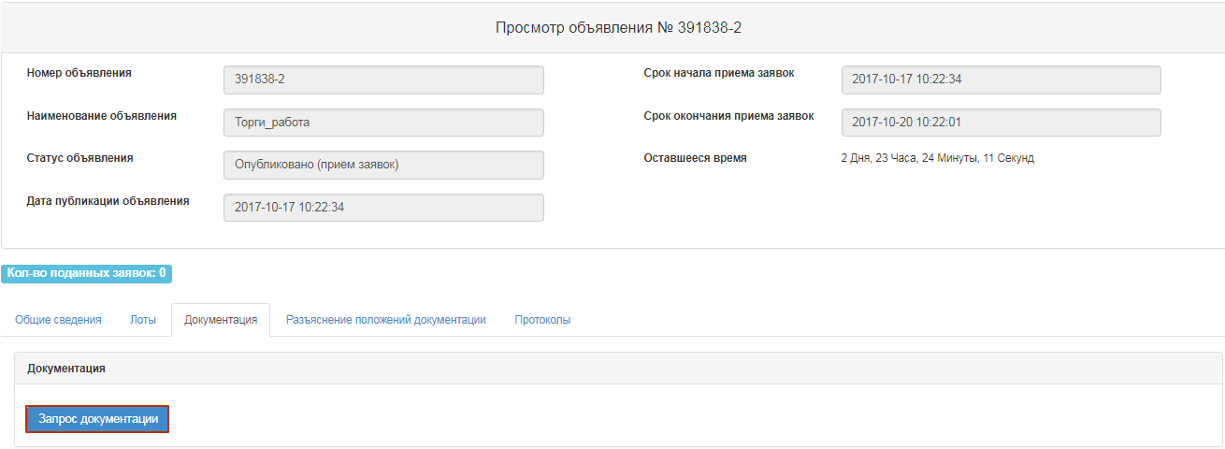
Then you must confirm the action.
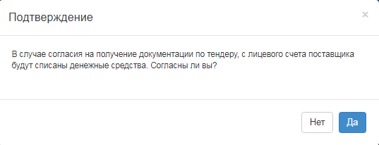
If successful, a list of documents is displayed. To view and download the document template, you should click the active link for the document name. Documents that are required to participate in the contest have a "Yes" sign. To view the generated document, click the "Go to" button.
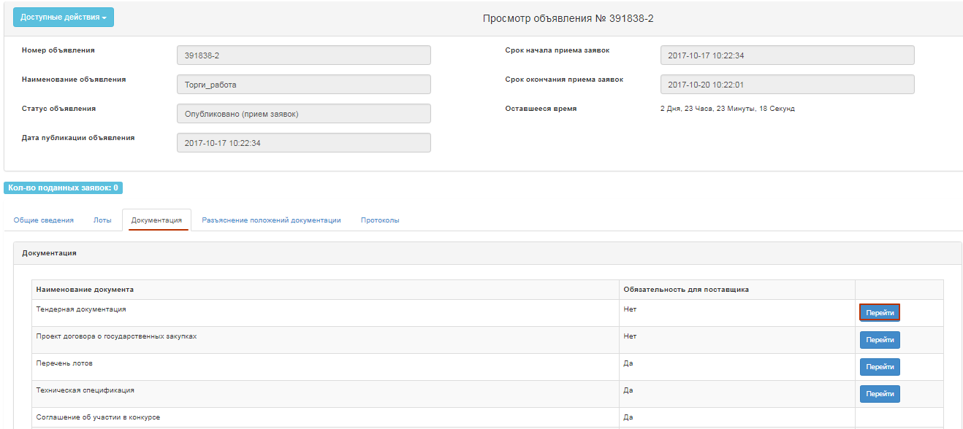
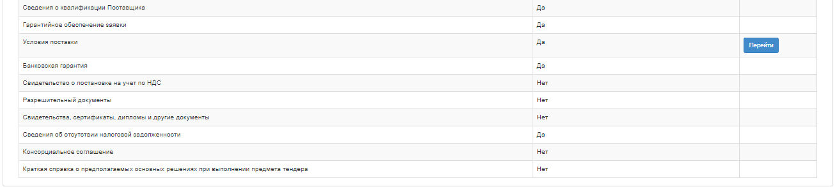
A form is displayed with information about the author and a link where you can download the file.
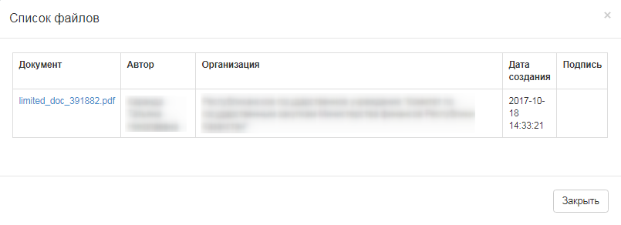

Clarification of the provisions of the documentation for the methods of procurement for "Unlimited bidding", "limited bidding", "Request for quotations"
Vendor may request clarification of the provisions of the documentation and/or comments on the draft documentation during the call for bids period with the status of "Published (Call for bids)".
To send a query, a user with the "Vendor" role has to go to the "Documentation clarification" tab in the announcement review form
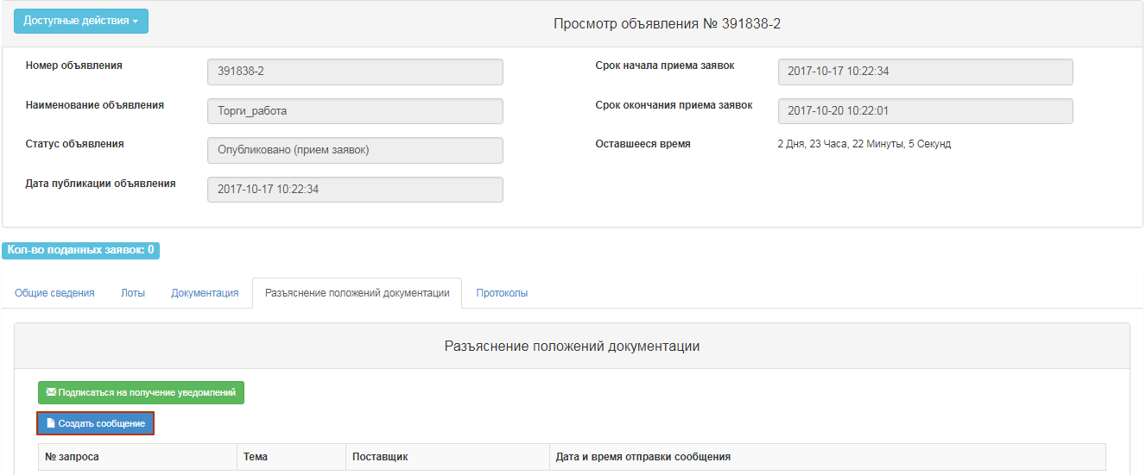
When you click the "Subscribe to Notifications" button, system allows you to subscribe to receive a notification that other vendors have sent the request to this request. When you click the "Unsubscribe to Notifications" button, the system allows the vendor to unsubscribe from receiving notification that other vendors have sent the request. When you click the "New Message" button, the following form is displayed
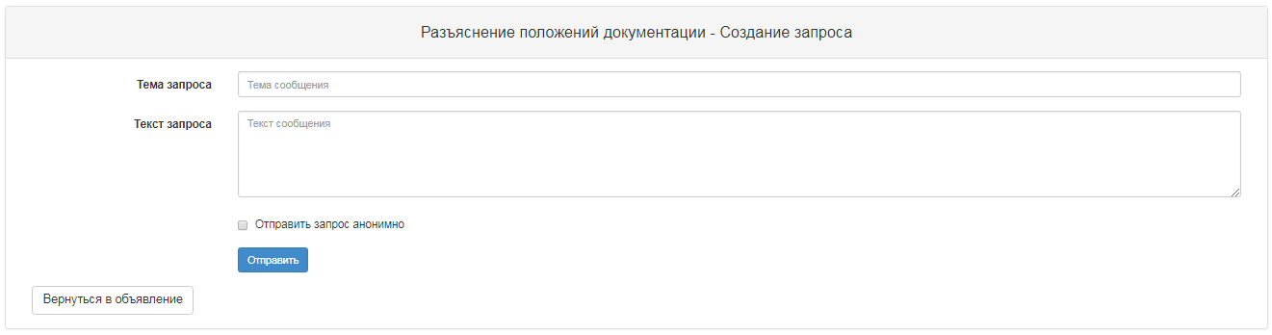
Field name | Description
Request type | Filled in manually. Select the following value:  Request for clarification of the BD;  A comment to the BD;
Request subject | Filled in manually
Request text | Filled in manually
Send | When clicking the button, System checks for filling in all mandatory fields  If the test is successful, system:  Saves the request and records the date and time when request was submitted, sends the notification to the personal account of the Secretary, Facilitator/customer representative, and members of the Commission about the request.
After request is created and sent, the "View message" form is displayed.
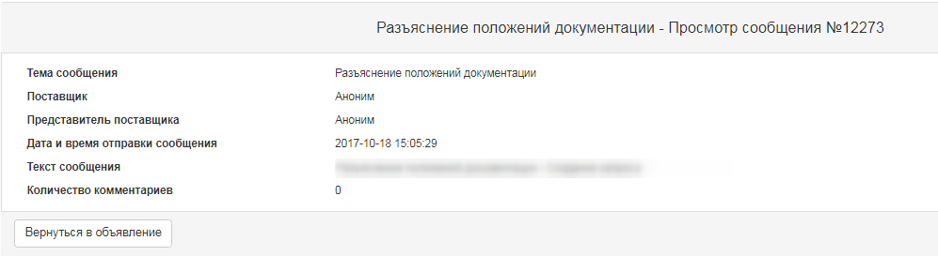
System will automatically send an anonymous message to clarify the documentation.

Discuss the documentation provisions for a "Single source" procurement method
Vendor may request clarification of the provisions of the documentation and/or comments on the draft documentation during the discussion period with the status of "Published".
To send a query, a user with the "Vendor" role has to go to the "Documentation clarification" tab in the announcement review form
When you click the "Subscribe to Notifications" button, system allows you to subscribe to receive a notification that other vendors have sent the request to this request. When you click the "Unsubscribe to Notifications" button, the system allows the vendor to unsubscribe from receiving notification that other vendors have sent the request. When you click the "New Message" button, the following form is displayed

Create and sbmit the bid
To submit a bid in the announcement view form, you must select "New bid" in the available actions.
Note. This action is available at the start date of call for bids, receipt of documentation (write-off), and the status of the announcement should be "Published (call for bids)".
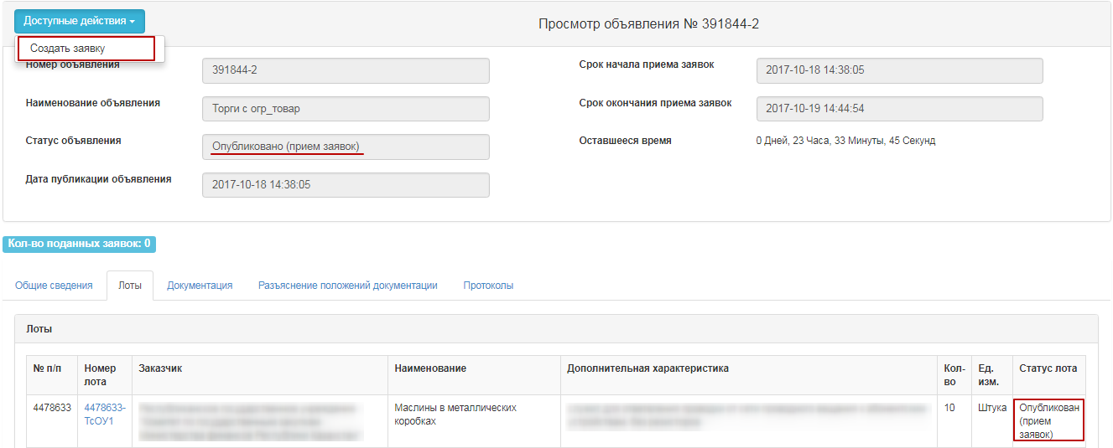
Form for creating the bid is displayed. Legal address and bank account must be specified.
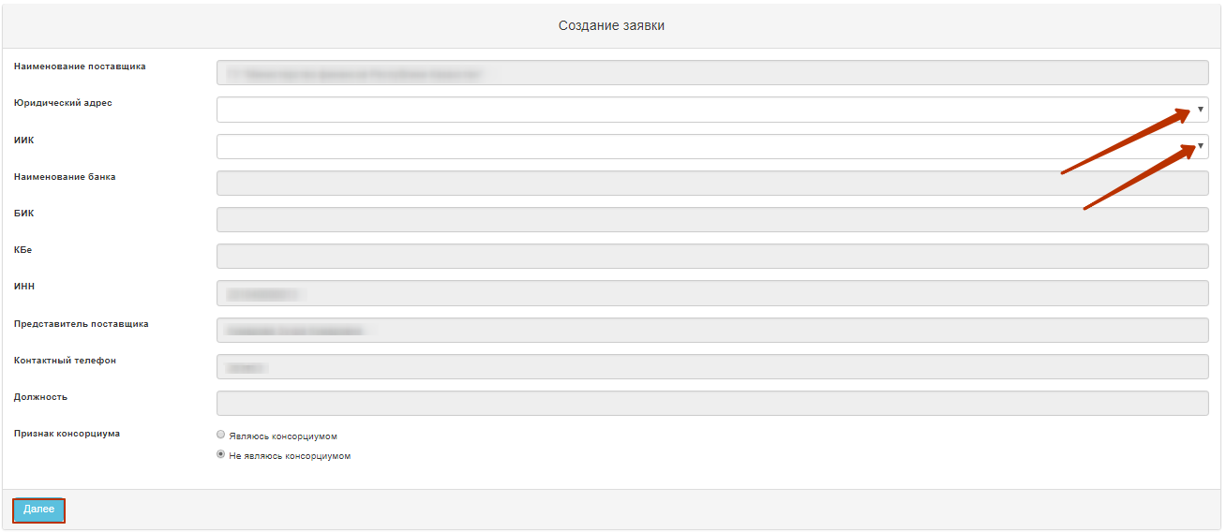
Note. In the case of "I'm a consortium", in the "Required" field, in the step of attaching the required documents, system will show "Required" in front of the "Consortium agreement" document.
To go to the next step, click "Next". The form for adding lots to purchase is displayed.
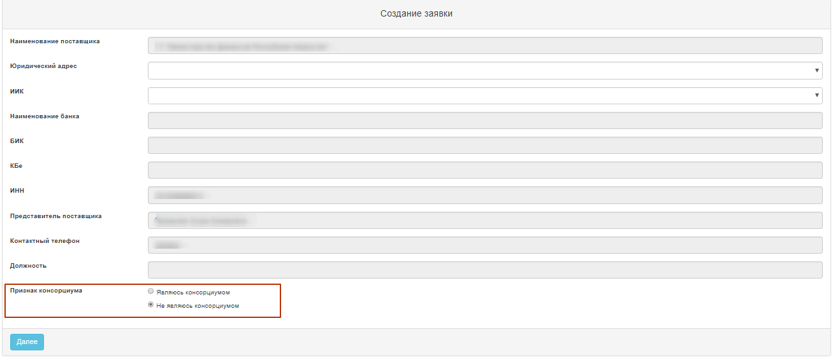

Add lots to participate in purchase
On the "Add lots to buy-in" form, vendor must note the required lot(s) and click the "Add Selected" button.
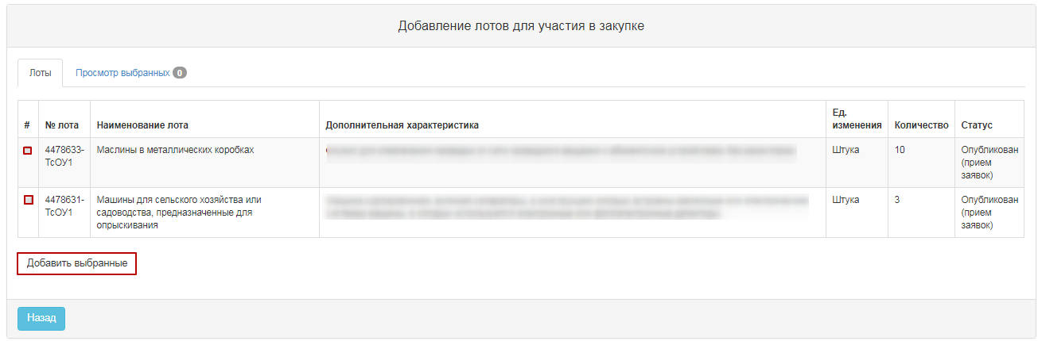
System will go to the "View selected" tab.
If you want to delete selected lot, mark required lot with a check mark and click "Delete lots from bid" button, and if you want to add lots to the purchase draft, go to the "Lots" tab and perform selection of lots.
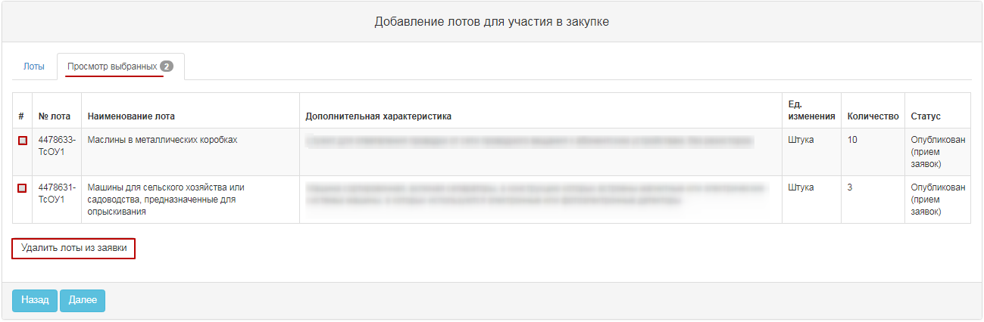
If you do not want to delete the selected lot, click "Next" to go to the next page.

Delete and edit a bid draft
To view the requisitions, go to the "Work account" - "My bids" Section
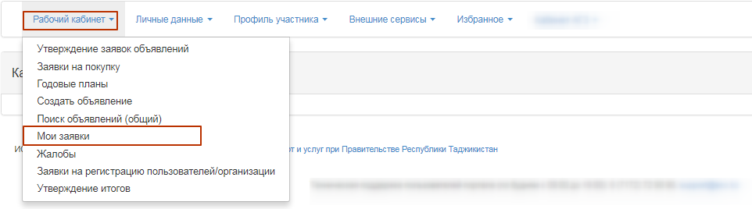
You can search for the desired bid by using a set of filters, and click the "Show Filter" button.
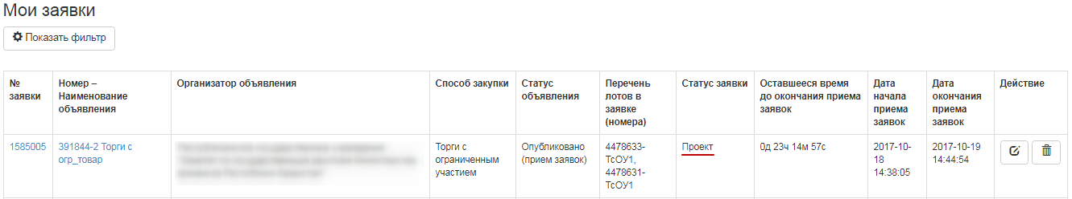
Deleting a bid is carried out by using an icon, editing is carried out with 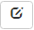an icon.

Attaching mandatory documents to participate in purchase
In the event that vendor needs to be provided with a document, the "Required" column will have a "Mandatory" sign.
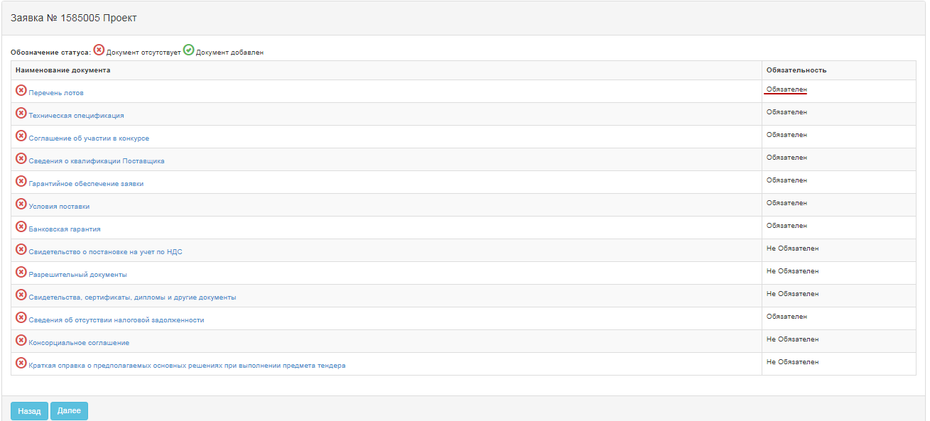
For such mandatory documents as "Vendor qualification Information", "Application Warranty", "Bank guarantee", "Tax debt absence information", a file attachment is required. To do this, you can use the file attachment functionality using the "Select File" button to open a window to find the file you want. After the file is selected, open it, and then click "Save".
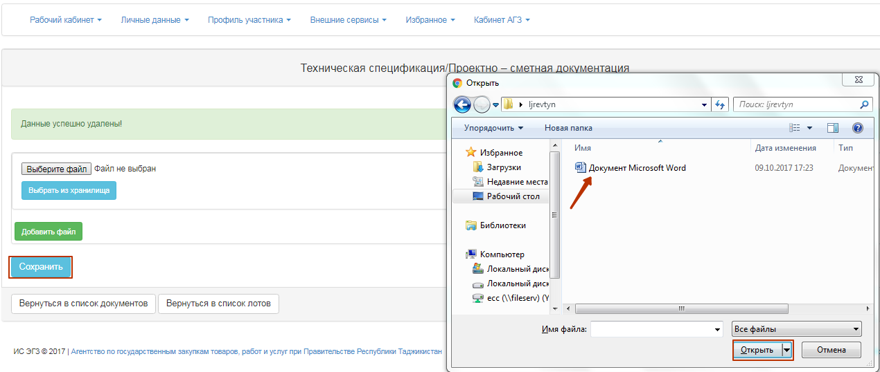
If you add a new file using the "Select from Storage" button, a window will open with previously downloaded files in the participant profile - File directory. After you select the file, you should "Save" it.
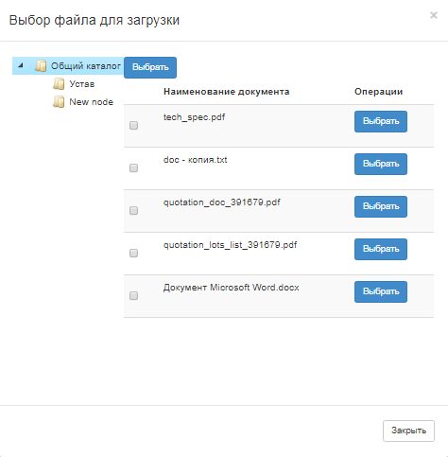

Create a purchase participation agreement
To form and confirm a purchase participation agreement, click the "Membership in the common document list agreement" link.
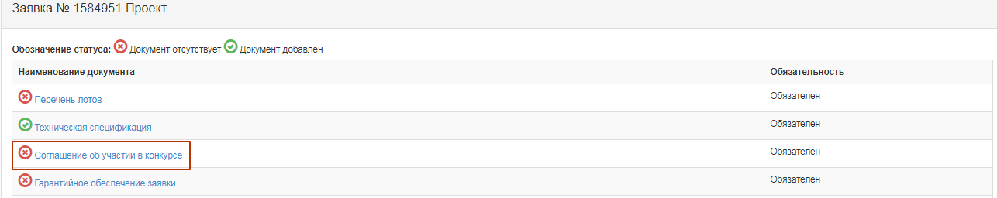
The agreement is displayed in the language selected in the interface. You must review the agreement and click the "Accept Agreement" button.
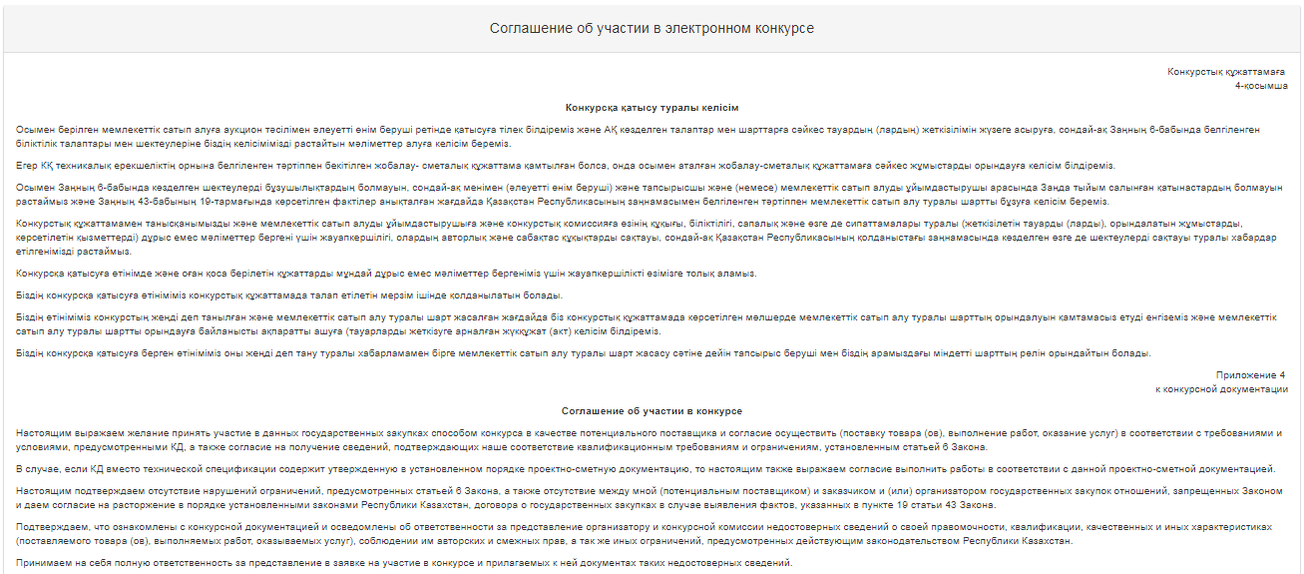
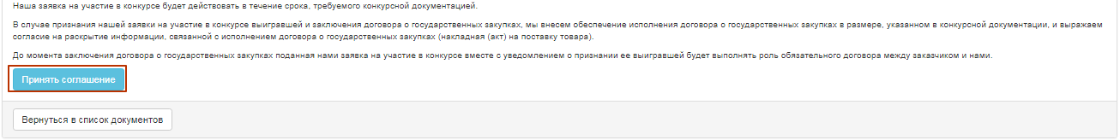
System forms a PDF file format. To view the agreement, click the active link for the file, and then click "Approve" to sign it.
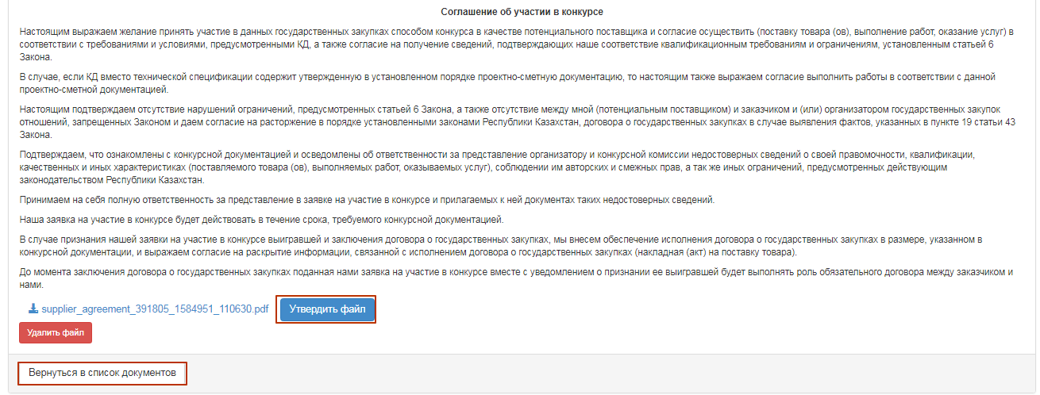
To return to the shared document list, click the "Return to document list" button.

Generating Technical Specification
To generate a technical specification, you must click the active "Technical specification" link in the Common Document list.
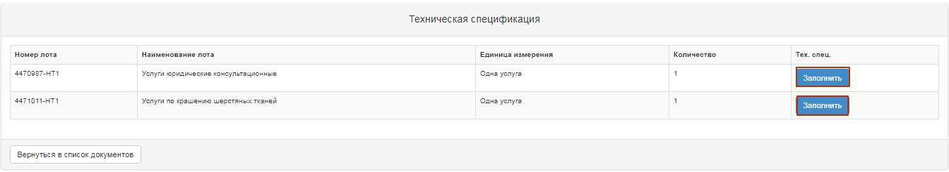
To generate the technical specification document, click "Fill" button.
"Work"/"Service" item shows the functionality for attaching files by clicking the "Select File" button to open a window to find the file you want. After the file is selected, open it, and then click "Save".
If you add a new file using the "Select from Storage" button, a window will open with previously downloaded files in the participant profile - File directory. After you select the file, you should "Save" it.
For "Goods" item, when you click "Fill", a form for editing is displayed.
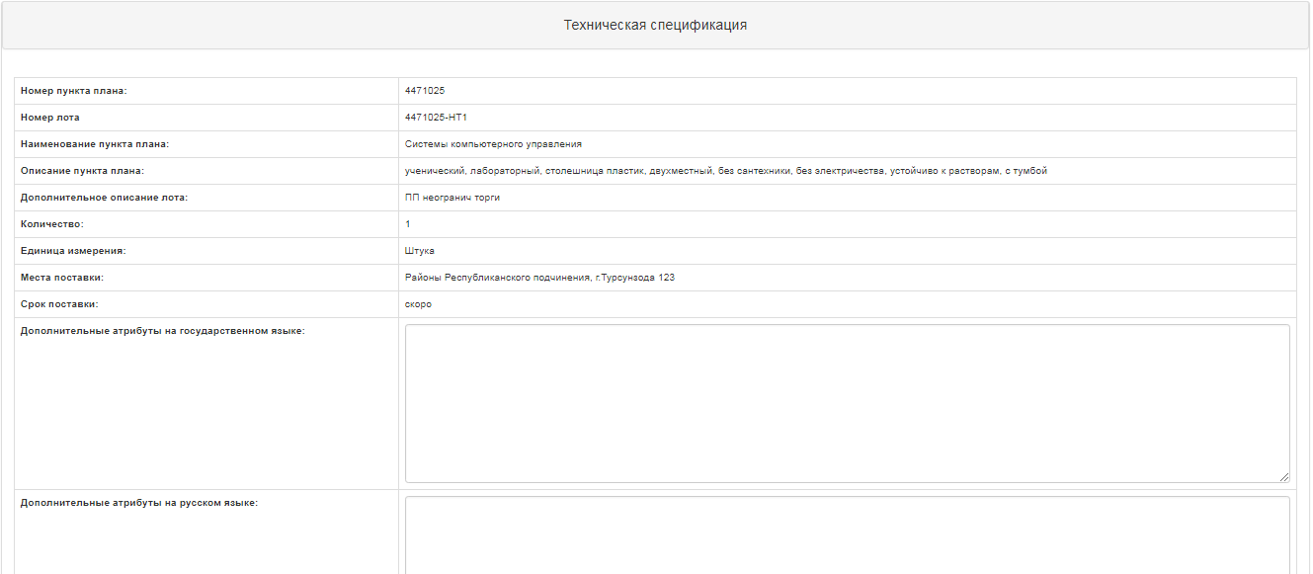
After changing click the "Save" button, and then click "Approve file". To return to the shared document list, click the "Return to document list" button.

Filling the "Delivery terms" document.
To fill click the active "Delivery terms" link in the General document list.
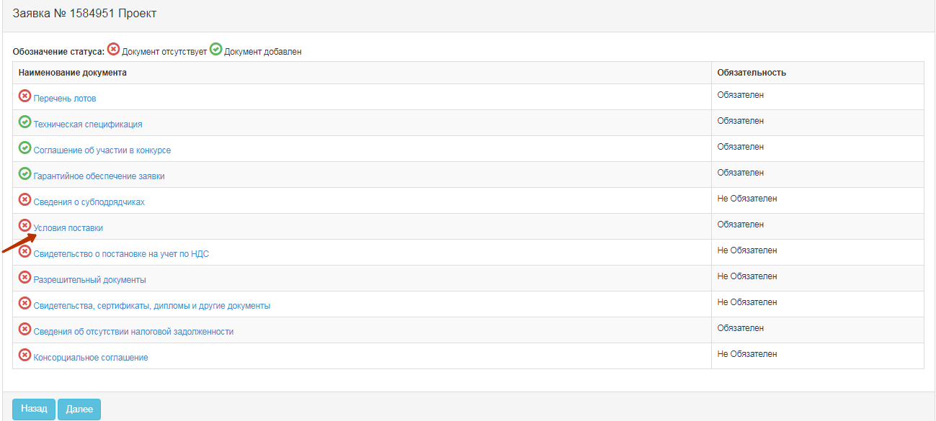
In the window that opens, click the "Fill" button for each announcement lot.
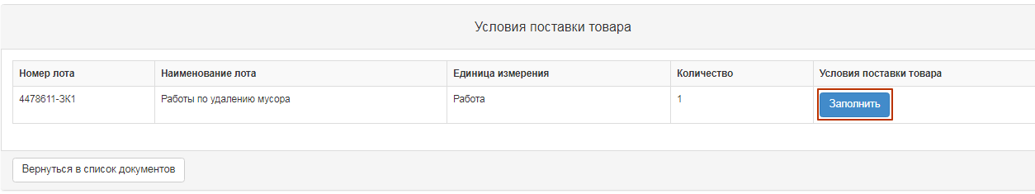
Next, you will see the form to fill out. You must fill in all the fields manually, save and then generate and approve the file.
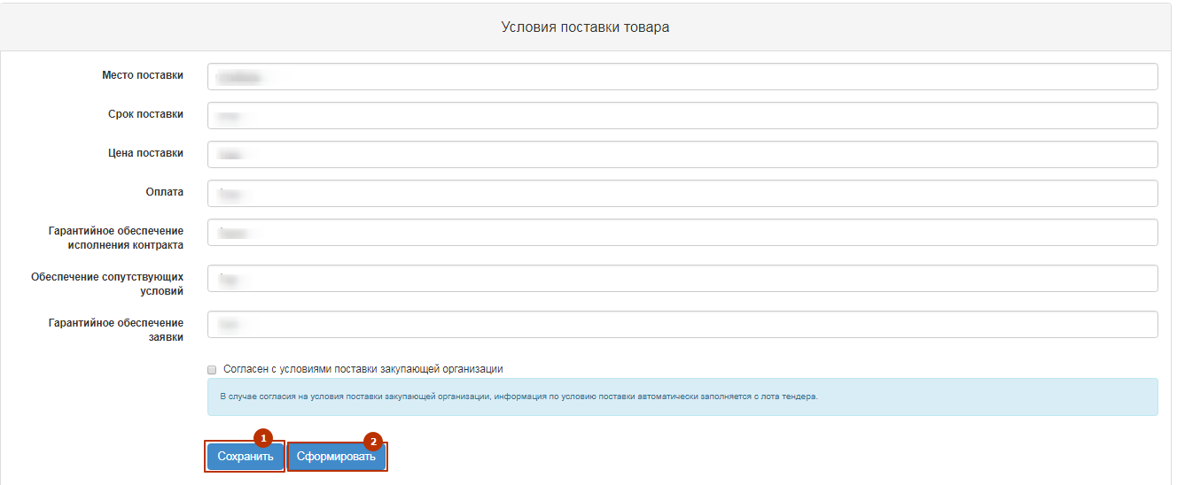
In the event of agreement to the terms of delivery of the procuring entity, information on the condition of delivery is automatically filled from the tender lot. To do this, vendor must mark the "Agree with the terms of delivery of the procuring entity", save and then generate and approve the file.
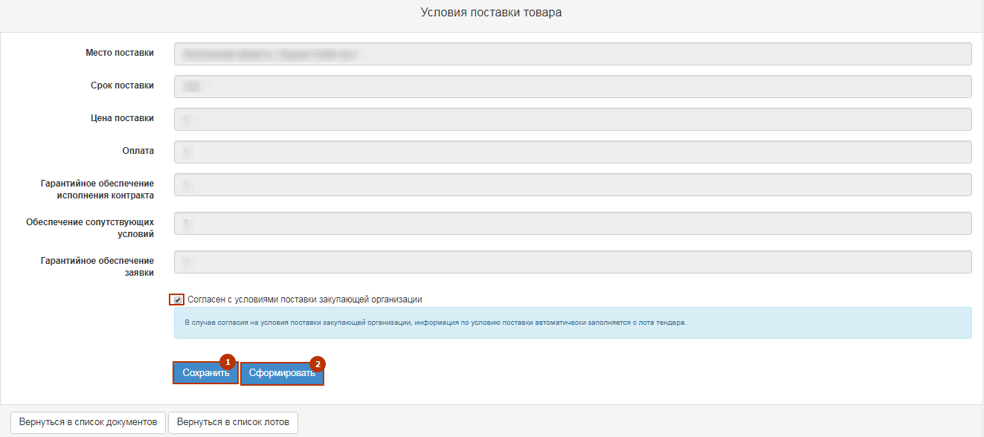

Generate a lot list
To generate a lot list, you must click the active "Lot list" link in the Common Document list.
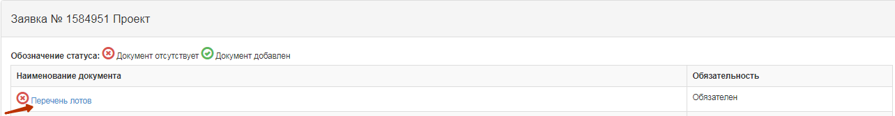
Window displays a list of the lots that the vendor participates in. You must click the "Generate Document" button. After a file is formed, you must approve it.
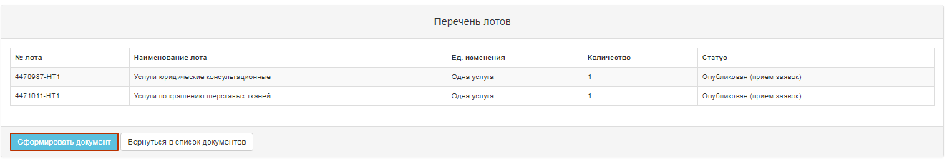

Fill in a price quote
When you have attached and signed all the required documents, the form for filling in the price quote is displayed. You must enter a price in the "Vendor Unit Price" field.
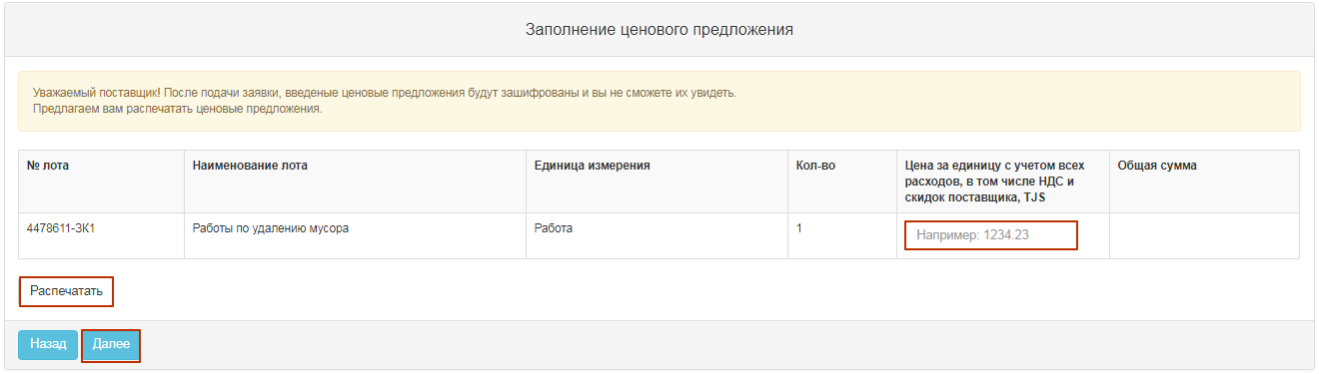
ATTENTION! After you submit your bid, the price quotes you enter will be encrypted and you won't be able to see them. You must click the "Print" button to save information about the vendor price.

Bid submission
A preview of the bid is displayed before the application is submitted. After the data is verified, you must click the "Submit bid" command.
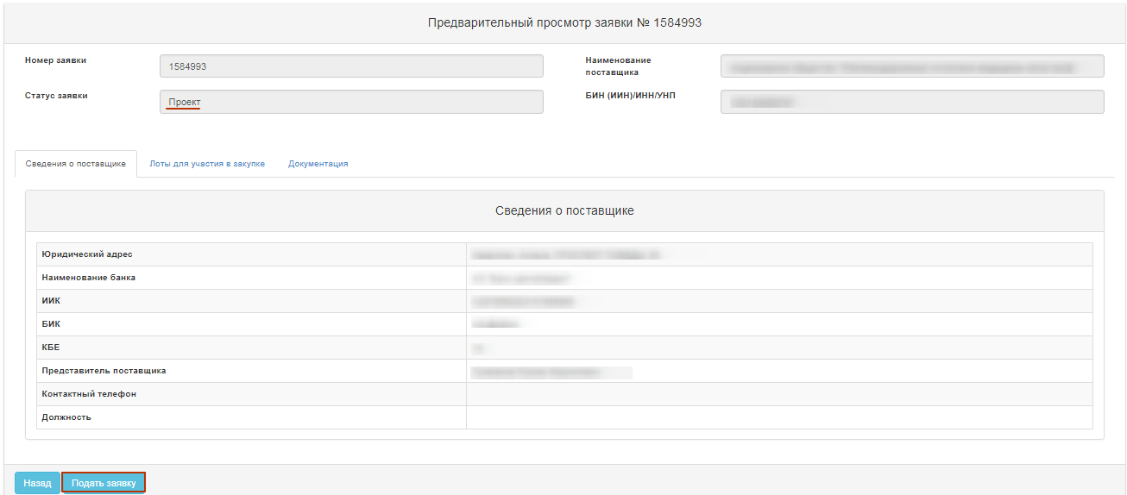
When you click on the "Submit bid", "Do you agree with the specified price quotation amount per lot(s)?"
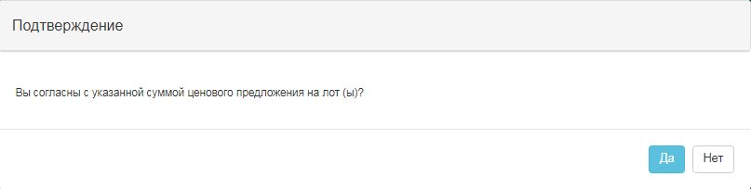
If successful, the bid moves to the "Submitted" status.
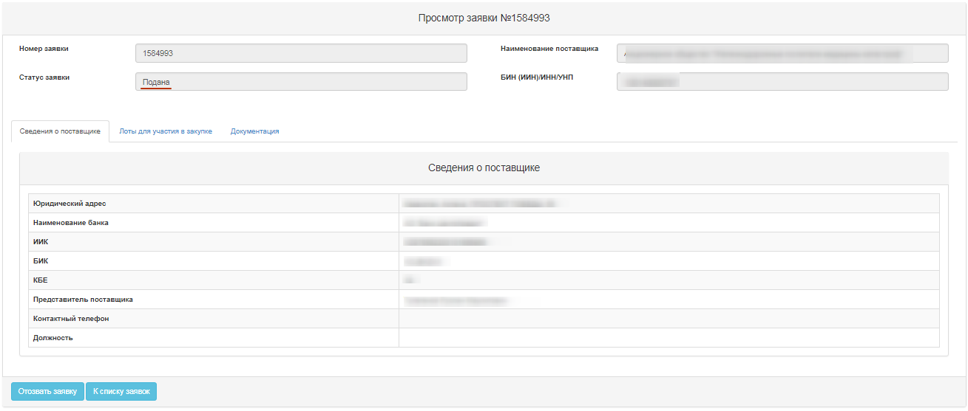

Clarification of the procurement methods for "Request for quotations", "limited bidding", "Tender with unlimited participation"
If the vendor has been rejected with a clarification, vendor's bid is set to "Rejected".
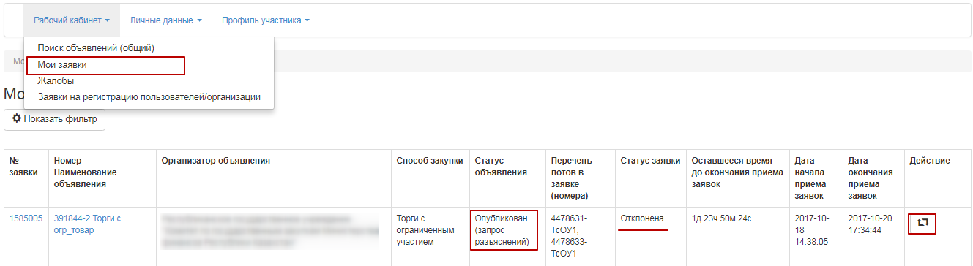
Note. The announcement status must be "Published (Request for clarifications)".
To search for a bid, go to the work account and select the "My quotes" menu, search for a bid using a set of filters. icon will be available in the "Action" field on the rejected bid line to supplement the bid by the call for bids start date. When you click the icon, a window appears asking you to confirm the action "Do you want to supplement the bid?"
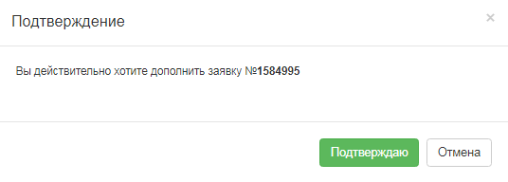
If confirmed, a lot/lots is displayed for which the rejection was performed and an explanation is requested.
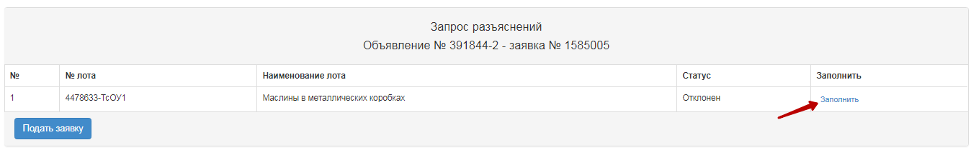
When you click "Fill", an explanation form where it is required to write the text of the clarification in the text box is displayed.
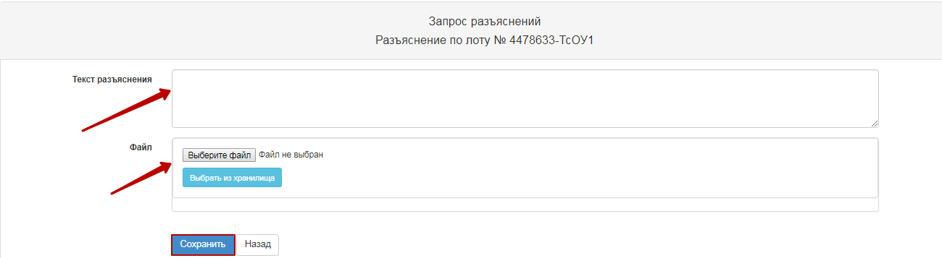
Note. If necessary, vendor has the option to attach the document. This optional function is not a requirement.
After you have filled in all the clarifications for each lot, you must click the "Submit bid" button.
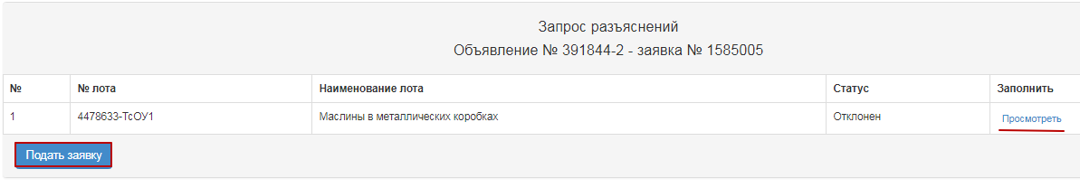
In the case of a successful submission, status is set to "Submitted (Request for clarifications)".
Note. An amended bid may be withdrawn, if necessary, before the end date of the call for clarifications by the pictogram.
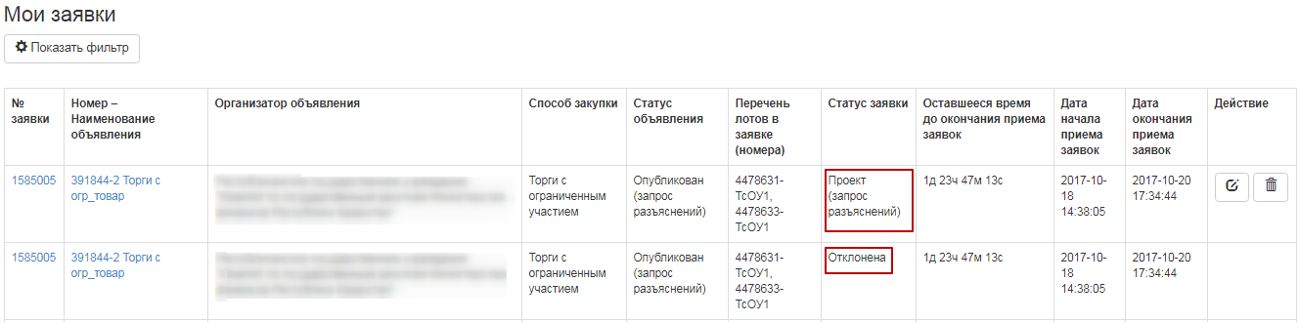
In the "My bids" section, two bids with identical numbers will be displayed for this announcement number. The original bid will have the status "Rejected".

Withdrawal of bids
If you need to withdraw the bid before the expiration date of the call for bids/(Request for clarification), the "Withdraw" action is available in the "My bids" section as a 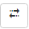 icon.
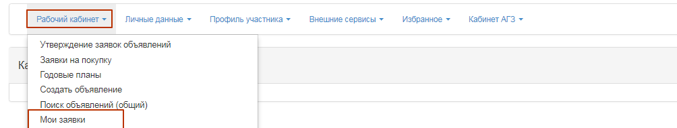
Note. Status of the bid must be "Submitted", "Submitted (Request for clarifications)", the announcement and the lot(s) with the status "Published (call for bids)", "Published (call for clarifications)"
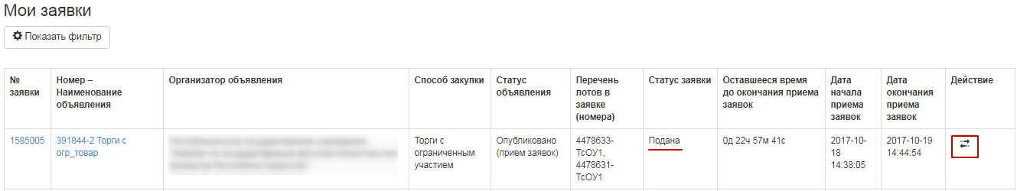
When you click the icon the "Action" box displays a window that requires you to confirm the action "Do you want to withdraw the request?".
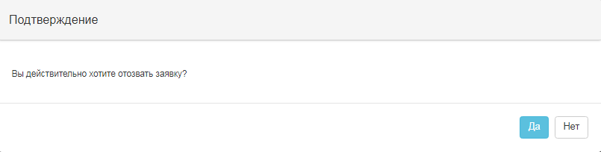
This feature is also available in the bid view form, using the "Withdraw bid" button.
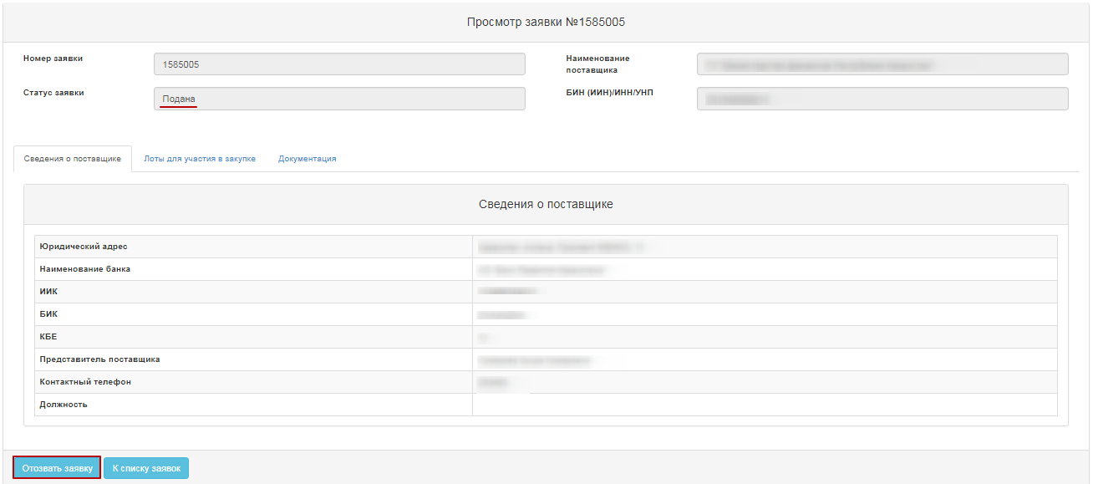
If the action is confirmed, the bid status is changed to "Withdrawn" ("Withdrawn (request for clarification)"), and a icon will be available in the Action field to edit the requisition or to delete the requisition.
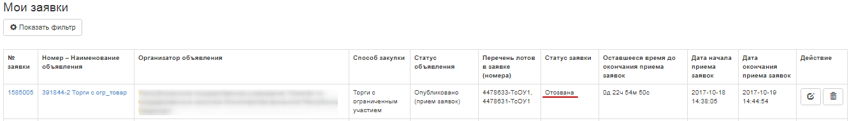

Filing a complaint by a vendor on the public procurement web portal

Creating and filing a complaint by a vendor
After the publication of the summary in the "limited bidding", "Tendering with unlimited participation" within 3 working days and for the "Request for quotations" method within 24 hours, vendor that involved the purchase, regardless of Results, has an option possible to lodge a complaint through the public procurement portal.
To do this, a user with the "Vendor" role must sign in to the work account - "Complaints" section
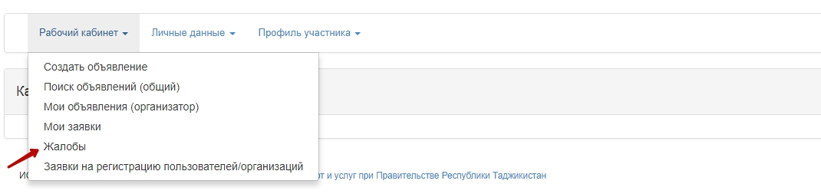
In the form of a complaint view, vendor is able to view the complaints sent from his or her organization and create a new complaint. To do this, click the "Create Complaint" button
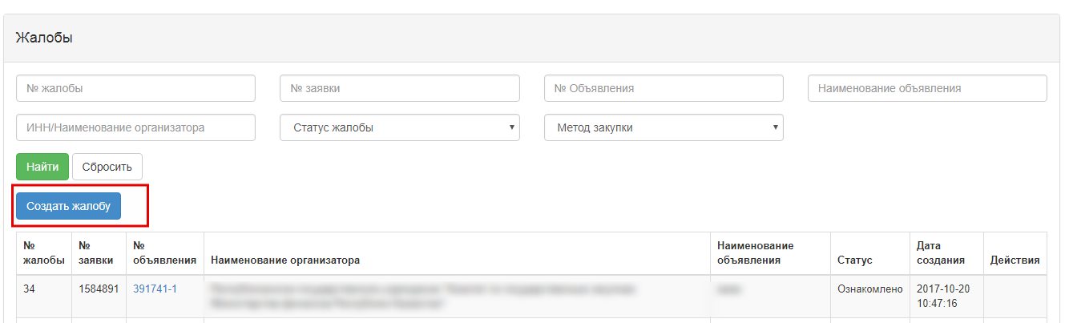
In the announcement selection form, you must search for a announcement in which the vendor has participated
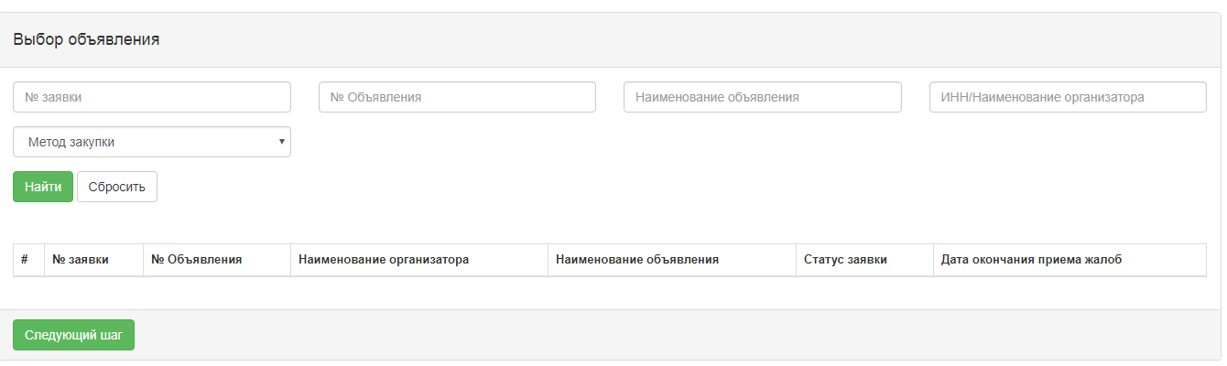
After you select an announcement, click the "Next step" button
Attention! The complaint creation is available at any stage after the publication of the summary protocol, but complaints that were received within 3 working days of the publication of the summary protocol of the "Tender Limited participation ", "Tender with unlimited participation "and 24 hours in the "Request for quotations" method will be received into the appeals process (results reconsideration or cancellation). After the mentioned period, complaints will be made available to the authorized body, but they will not be decided upon on the portal.
After you have selected an announcement to make a complaint, you must select the lots that will be complained on on the lot adding form.
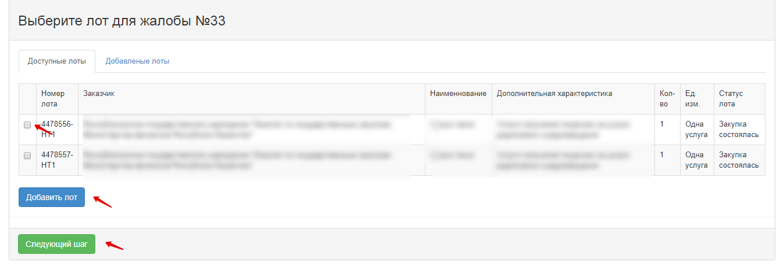
After you select the lot, you must enter the complaint text on the application and attach the document, if necessary
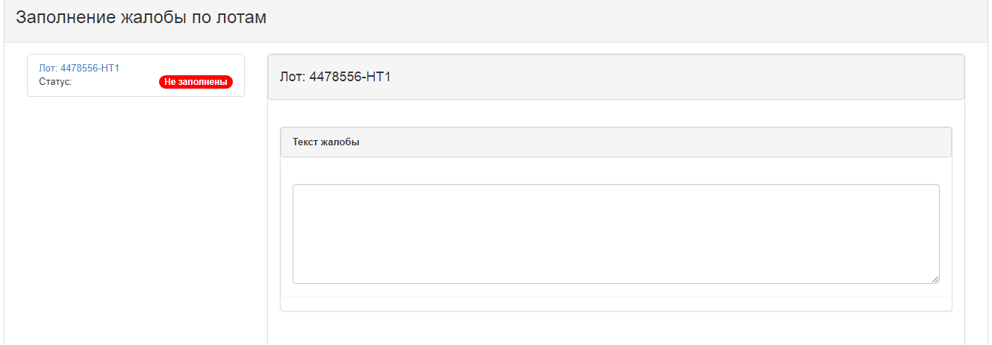
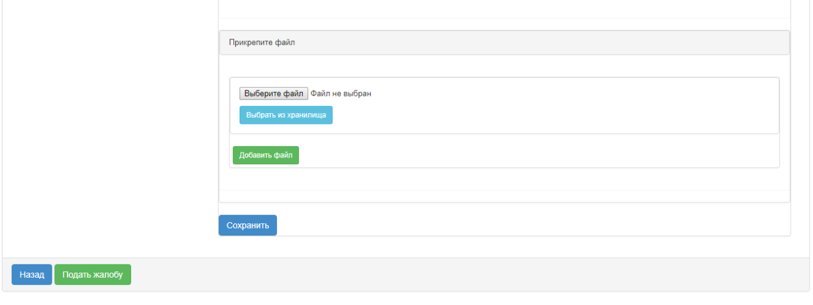
After you have filled in the lot complaint text, click "Save". Then, if a complaint is filed against multiple lots, you will need to go to the other lot to prepare the text of the complaint for the next lot. The text of complaint is filled separately for each lot.
After you fill in the complaint text for each lot and save the data, vendor needs to press the "File a complaint" button.
If, for any lot, the text of complaint is not filled in, system will issue a message when the complaint is filed
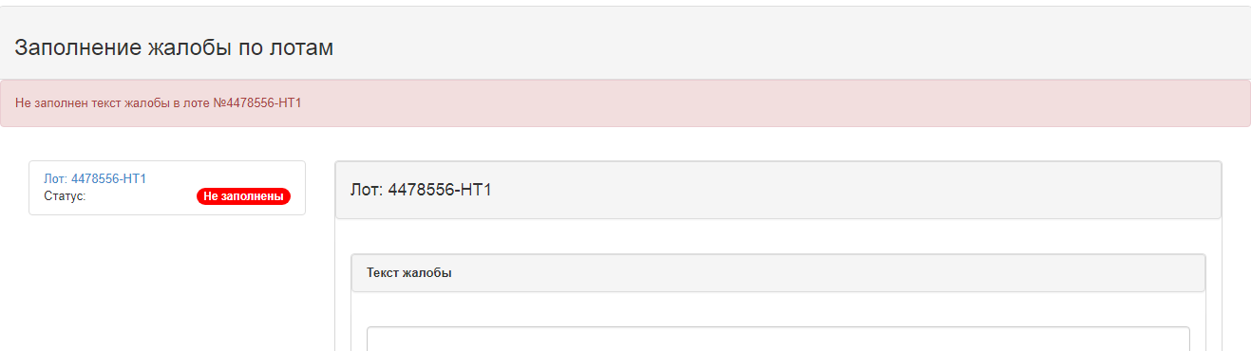
The status of the complaint is set to "Submitted".

Editing a complaint by a vendor
To edit a complaint, vendor must select the complaint in the "Draft" and "Rejected" status of the complaint form and click the "Edit" icon
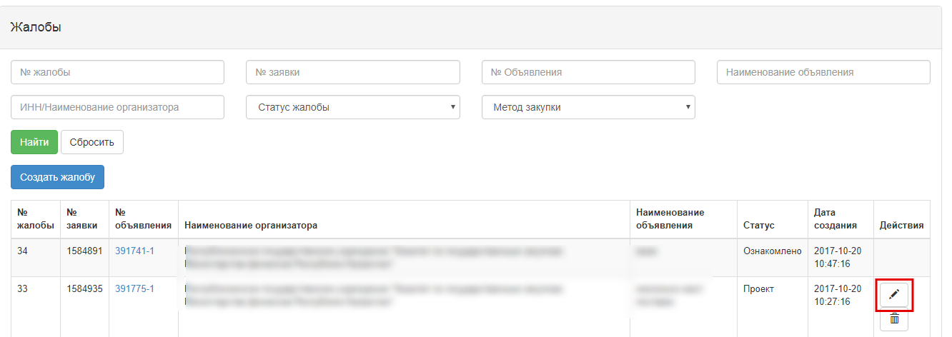
When you click the "Edit" icon, a form to edit the complaint opens.

Deleting a complaint draft by a vendor
To delete a complaint, vendor must select a complaint in the "Draft" status in the view form of the Organization's complaints and click the "Delete" icon
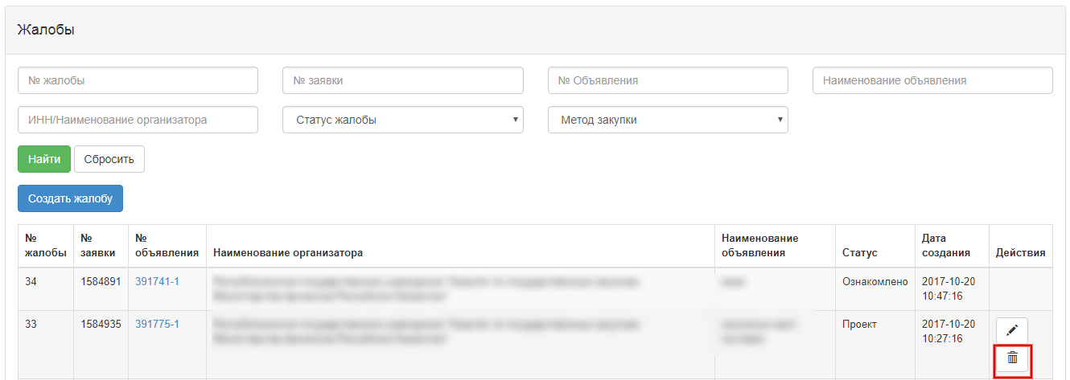
Procedure for removing the draft complaint will have to be confirmed
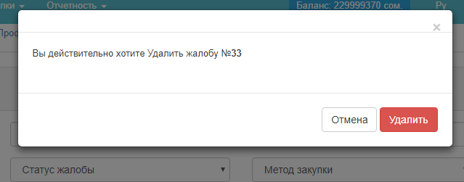

Withdrawing the complaint by vendor
In order to withdraw the complaint, vendor must, in the form of a complaint, select the complaint in the status of "Submitted" and click the "Withdraw" icon
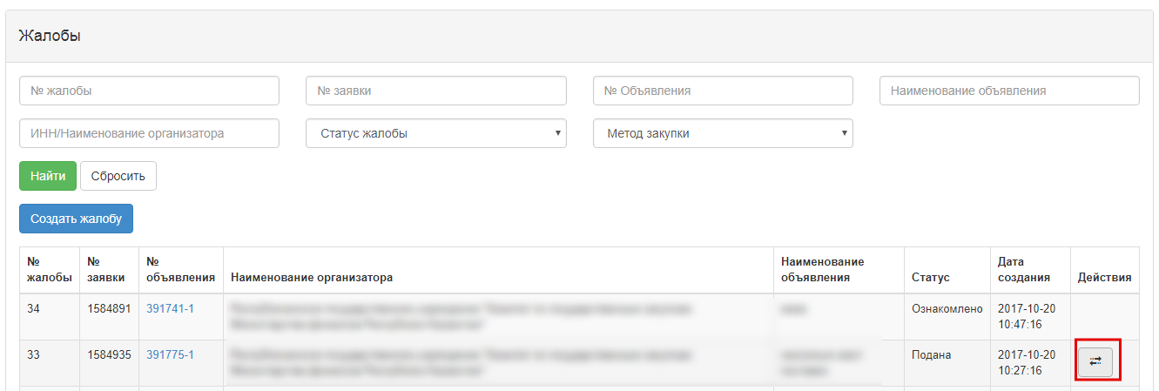
Attention! Withdrawal of the complaint is available only if the time limit for the receipt of complaints has not expired and if the complaint has not been brought to an end.

